Institute of Computer Technology

B. Tech Computer Science and Engineering

Sub: Database Management System (2CSE301)

Practical 1: To create database and insert records in the tables.

Scenario: Mohan who is a Computer Engineer seeking to start Computer Parts & Accessories Shop. They are planning to build Website and Application for which they met with IT Professionals and gave their requirements to develop the same. Now based on information gathered, IT Company is initiating to create Database.

# A) Table Name: Client_master

Description: Used to store information about clients.

|  |  |  |
| --- | --- | --- |
| **Column Name** | **Data Type** | **Size** |
| Client_no | Varchar | 6 |
| Name | Varchar | 20 |
| Ciy | Varchar | 15 |
| Pincode | Numeric | 8 |
| State | Varchar | 15 |
| Bal_due | Numeric | 10,2 |

# B) Table Name: Product_master

Description: Used to store information about products.

|  |  |  |
| --- | --- | --- |
| **Column Name** | **Data Type** | **Size** |
| Product_no | Varchar | 6 |
| Description | Varchar | 15 |
| P_percent | Numeric | 4,2 |
| U_measure | Varchar | 10 |
| Qty_on_hand | Numeric | 8 |
| Reorder_lvl | Numeric | 8 |
| Sell_price | Numeric | 8,2 |
| Cost_price | Numeric | 8,2 |

# C) Table Name: Salesman_master

Description: Used to store information about salesman working in the company.

|  |  |  |
| --- | --- | --- |
| **Column Name** | **Data Type** | **Size** |
| S_no | Varchar | 6 |
| S_name | Varchar | 20 |
| City | Varchar | 20 |
| Pincode | Numeric | 8 |
| State | Varchar | 20 |
| Sal_amt | Numeric | 8,2 |
| Tgt_to_get | Numeric | 6,2 |
| Ytd_sales | Numeric | 6,2 |
| remarks | Varchar | 12 |

# A) Table Name: Client_master

|  |  |  |  |  |  |
| --- | --- | --- | --- | --- | --- |
| **Client_no** | **Name** | **City** | **Pincode** | **State** | **Bal_due** |
| C001 | Ivan | Bombay | 400054 | Maharashtra | 15000 |
| C002 | Vandana | Madras | 780001 | Tamil Nadu | 0 |
| C003 | Pramada | Bombay | 400057 | Maharashtra | 5000 |
| C004 | Basu | Bombay | 400056 | Maharashtra | 0 |
| C005 | Ravi | Delhi | 100001 | Gujarat | 2000 |
| C006 | Rukmani | Bombay | 400050 | Maharashtra | 0 |

# B) Table Name: Product_master

|  |  |  |  |  |  |  |  |
| --- | --- | --- | --- | --- | --- | --- | --- |
| Product_ No | Description | P_ percent | U_  Measure | Qty_on_ hand | Reorder_  lvl | sell_ price | Cost_ price |
| P001 | Floppies | 5 | Piece | 100 | 20 | 525 | 500 |
| P002 | Monitor | 6 | Piece | 10 | 3 | 12000 | 11280 |
| P003 | Mouse | 5 | Piece | 20 | 5 | 1050 | 1000 |
| P004 | Floppies | 5 | Piece | 100 | 20 | 525 | 500 |
| P005 | Keyboards | 2 | Piece | 10 | 3 | 3150 | 3050 |
| P006 | Cd Drive | 2.5 | Piece | 10 | 3 | 5250 | 5100 |
| P007 | 1.44 Drive | 4 | Piece | 10 | 3 | 8400 | 8000 |

# C) Table Name: Salesman_master

|  |  |  |  |  |  |  |  |  |
| --- | --- | --- | --- | --- | --- | --- | --- | --- |
| S_no | S_name | City | Pin | State | Sal_ Amt | Tgt_ to get | Ytd_ Sales | Remarks |
| S001 | Kiran | Bombay | 400002 | Maharashtar | 3000 | 100 | 50 | Excellent |
| S002 | Manish | Bombay | 400001 | Maharashta | 3000 | 200 | 100 | Good |
| S003 | Ravi | Bombay | 400032 | Maharashta | 3000 | 200 | 100 | Average |
| S004 | Ashish | Bombay | 400044 | Maharashta | 3500 | 200 | 150 | Good |

**Exercise:**

1. Create database in mysql with your branch name and enrollment number.
2. Create table client_master.
3. Create table product_master.
4. Create table salesman_master.
5. Describe structure for client_master table.
6. Describe structure for product_master table.
7. Describe structure for salesman_master table.
8. Insert records in client_master table.
9. Insert records in product_master table.
10. Insert records in salesman_master table.
11. Retrieve all records for client_master table.
12. Retrieve product_no, sell_price and cost_price for product_master table.
13. Retrieve s_no,s_name, remarks and sal_amt for salesman_master table.
14. Display all tables for your database.

**Solutions: Commands**

create database cs_22162171038;

use cs_22162171038;

create table client_master(Client_no varchar(6),Name varchar(20),Ciy varchar(15),Pincode Numeric(8),State Varchar(15),Bal_due Numeric(10,2));

create table product_master(Product_no Varchar(6),Description Varchar(15),P_percent Numeric(4,2),U_measure Varchar(10),Qty_on_hand Numeric(8),Reorder_lvl Numeric(8),Sell_price Numeric(8,2),Cost_price Numeric(8,2));

create table salesman_master(S_no Varchar(6),S_name Varchar(20),City Varchar(20),Pincode Numeric(8),State Varchar(20),Sal_amt Numeric(8,2),Tgt_to_get Numeric(6,2),Ytd_sales Numeric(6,2),remarks Varchar(12));

desc client_master;

desc product_master;

desc salesman_master;

insert into client_master values('C001', 'Ivan', 'Bombay', 400054, 'Maharashtra', 15000);

insert into client_master values('C002', 'Vandana', 'Madras', 780001, 'Tamil Nadu', 0);

insert into client_master values('C003', 'Pramada', 'Bombay', 400057, 'Maharashtra', 5000);

insert into client_master values('C004', 'Basu', 'Bombay', 400056, 'Maharashtra', 0);

insert into client_master values('C005', 'Ravi', 'Delhi', 100001, 'Gujarat', 2000);

insert into client_master values('C006', 'Rukmani', 'Bombay', 400050, 'Maharashtra', 0);

insert into product_master values('P001', 'Floppies', 5, 'Piece', 100, 20, 525, 500);

insert into product_master values('P002', 'Monitor', 6, 'Piece', 10, 3, 12000, 11280);

insert into product_master values('P003', 'Mouse', 5, 'Piece', 20, 5, 1050, 1000);

insert into product_master values('P004', 'Floppies', 5, 'Piece', 100, 20, 525, 500);

insert into product_master values('P005', 'Keyboards', 2, 'Piece', 10, 3, 3150, 3050);

insert into product_master values('P006', 'Cd Drive', '2.5', 'Piece', 10, 3 ,5250, 5100);

insert into product_master values('P007', '1.44 Drive', 4, 'Piece', 10, 3, 8400, 8000);

insert into salesman_master values('S001', 'Kiran', 'Bombay', 400002, 'Maharashtar', 3000, 100, 50, 'Excellent');

insert into salesman_master values('S002', 'Manish', 'Bombay', 400001, 'Maharashta', 3000, 200, 100, 'Good');

insert into salesman_master values('S003', 'Ravi', 'Bombay', 400032, 'Maharashta', 3000, 200, 100, 'Average');

insert into salesman_master values('S004', 'Ashish', 'Bombay', 400044, 'Maharashta', 3500, 200, 150, 'Good');

select * from client_master;

select * from product_master;

select * from salesman_master;

**Tables:**

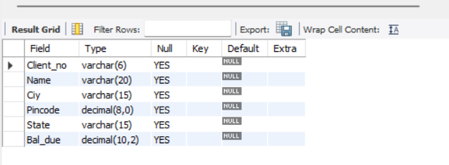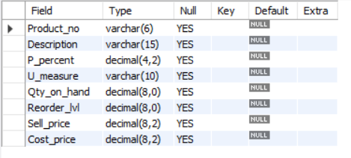

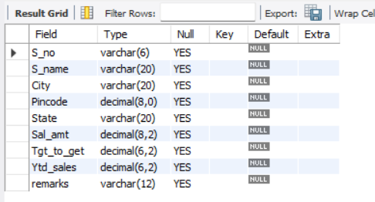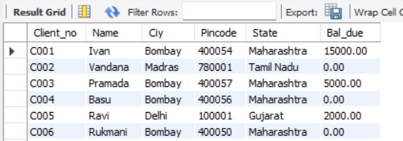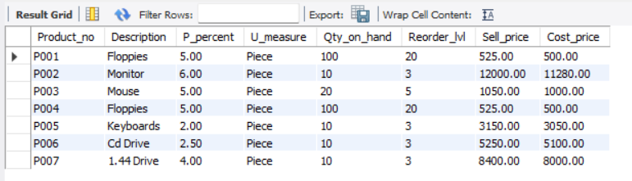

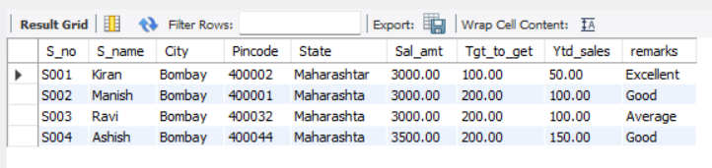

**Commands Execution:**

